# NDVI Tools

## Purpose

This module offers a set of functions for image stacks. These functions are:

* Normalize indices; this allows the user to calculate NDVI, VCI and TCI indices with actual values or as percentages
* Calculate Drought index
* Normalize NDVI to RPD (Relative phenological development)
* Find first value above a threshold at user defined places in time series
* Calculate winter NDVI to cope with high latitude conditions in winter period (northern hemisphere)
* Calculate the GDD (Growing Degree Days)
* Determine the start of the season and from that moment output the first NDVI values.

## Installation

Install the .sav files in the save_add folder (see also [ENVI .sav files: Installation and configuration](http://www.itc.nl/personal/nieuwenh/installations.html).

_nrsmenu.sav Define NRS menu item in ENVI

nrs_Utils.sav Library with utility routines

nrs_NDVI_tools.sav The actual software

## Usage (gui)

|  |  |
| --- | --- |
| NRS_NORMALIZE_GUI | Start the user interface of the normalizing. |
| NRS_DROUGHT_GUI | Start the user interface of the drought index calculation. |
| nrs_rpd_gui | Start the user interface of the relative phenological development (RPD) calculation |
| nrs_rpd_perc_gui | Start the user interface to find the first time/band where GWI is over a threshold |
| nrs_winter_ndvi_gui | Start the user interface of the winter NDVI calculation |
| nrs_growing_degree_days_gui | Start the user interface for the GDD calculation |
| nrs_growth_gui | Start the user interface for the season start determination |

Alternatively the commands can be started from the ENVI menu: ‘NRS | NDVI’:

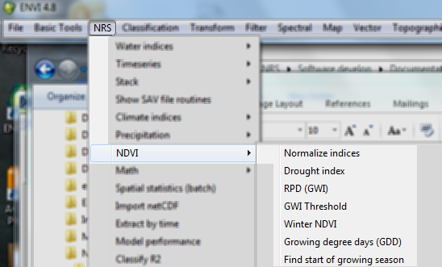

### Normalize indices

Menu option is ‘NRS | NDVI | Normalize indices, the command line is ‘nrs_normalize_gui’. This function determines the value at a certain point in time between the long term minimum and maximum value of the complete or yearly periods. It can either calculate the new value over the minimum (1) or over the maximum (2):

${index}_{min}=\left(\frac{x-x_{min}}{x_{max}-x_{min}}\right)$ (1)

${index}_{max}=\left(\frac{x_{max}-x}{x_{max}-x_{min}}\right)$ (2)

Also the indices can be calculated as percentages (multiplying them by 100).

For example the VCI (Vegetation Condition Index) is calculated with formula (1), while the TCI (Temperature Condition Index) is calculated with formula (2).

The user interface is shown below:

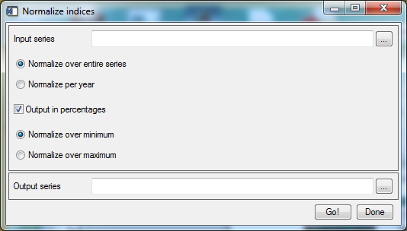

Explanation of all the fields:

|  |  |
| --- | --- |
| Input series | Select an input NDVI time series; |
| Normalize over entire series | If selected the minimum and maximum values are calculated over the entire series, before applying the normalization formula. |
| Normalize per year | If selected the minimum and maximum values are calculated per year and the normalization is restarted for each year. This version of the software assumes 36 NDVI images per year. |
| Output in percentages | If switched on will calculate the index as a percentage by multiplying the index with 100% |
| Normalize over minimum | Use formula (1) |
| Normalize over maximum | Use formula (2) |
| Output series | The filename of the output time series. |

### Drought index

Menu option is ‘NRS | NDVI | Drought index, the command line is ‘nrs_drought_gui’. The drought index is defined as (Kogan 1995):

$V/TCI=0.7×VCI+0.3×TCI$ (3)

The user interface is shown below:

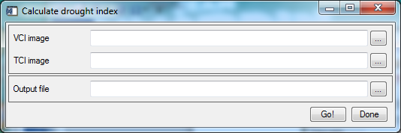

Explanation of all fields:

|  |  |
| --- | --- |
| VCI image | Select the VCI |
| TCI image | Select the TCI image |
| Output file | The filename of the output file. |

### Relative phenological development

Menu option is ‘NRS | NDVI | RPD (GWI), the command line is ‘nrs_rpd_gui’. This function normalizes NDVI using the formula:

$rpd= \frac{\left(ndvi-{ndvi}_{min}\right)}{\left({ndvi}_{max}-{ndvi}_{min}\right)}$ (4)

It is also referred to as Green Wave Index (GWI).

The user interface is shown below:

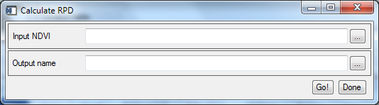

Explanation of the fields:

|  |  |
| --- | --- |
| Input NDVI | Select the NDVI time series |
| Output name | The filename of the output file. |

### GWI threshold

Menu option is ‘NRS | NDVI | GWI Threshold, the command line is ‘nrs_rpd_perc_gui’. Given a set of locations (in geographic coordinates), find the first band index in the time series at each location which is higher than a percentage of the range. Currently the range is fixed between 0.0 and 1.0, meaning that the percentage corresponds with the actual value. It also means that for accurate results indices to be checked need to be normalized first (for example with one of the normalization functions above).

Invalid input values, that is, when all values are lower than the percentage, the output will be -1.

With a window only valid profiles are used for averaging.

In case of daily input data the index is the actual day of the year (DOY) and this is indicated in the output as well.

The user interface is shown below:

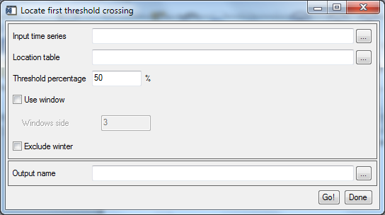

Explanation of the fields:

|  |  |
| --- | --- |
| Input time series | Select the NDVI time series. One years’ worth of data is assumed. Multi-year data is accepted but does not give correct results. |
| Location table | Select the CSV table with two columns containing the coordinates of all locations (as latitude, longitude). The software will recognize the order of the columns if the names for the columns are *lat* and *lon.* |
| Threshold percentage | The threshold value in percentages of the range between minimum and maximum values of the input time series. (For RPD / GWI this range is 0.0 to 1.0, so the percentage corresponds with the actual value in the input) |
| Use window | Tick this option to enable specifying a square area with the location in the middle. The neighboring locations in the area are averaged to a single profile, which is then used to find the first crossing. By default only the actual location is used to determine the first crossing. |
| Window side | Specify the window side of the area around the location |
| Exclude winter | Tick this option to only consider the period from 1 March to 1 November. This is limited to the northern hemisphere. |
| Output name | The filename of the output file. This will be the same table as the input, with an additional column, containing the band index where the RPD / GWI value is higher than the percentage for the first time. |

### Growing degree days

Menu option is ‘NRS | NDVI | *Growing degree days*, the command line is ‘nrs_growing_degree_days_gui’. This module calculates the accumulated temperature (in degrees Celsius), and optionally also the GDD-jerk and the onset of spring based on the GDD. GDD-jerk indicates the highest growth of daily temperatures (van Wijk, Kölzsch et al. 2012). Spring start is calculated as the band number where the GDD exceeds 180 degrees for the first time.

The input time series is assumed to have onlylimited to one season.

The Tbase formula uses latitude values to determine the development threshold temperature at a location. The use of latitudes forces the input image to have a geographic coordinate system or a projected coordinate system that can reproject to geographic coordinates. The default values for the slope and intercept for the Tbase formula will set the Tbase to a fixed value of zero. For wide geographical ranges it is advised to perform a linear regression on the threshold temperature values at the latitude boundaries.

The user interface is shown below:

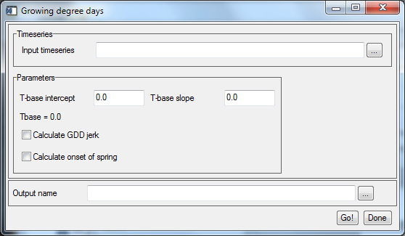

Explanation of the fields:

|  |  |
| --- | --- |
| Input timeseries | Select the time series with temperature data (in degrees Celcius) |
| T-base intercept | The intercept value for the Tbase formula |
| T-base slope | The slope value for the Tbase formula |
| Tbase | Shows the formula used to calculate the Tbase as a function of the latitude |
| Calculate GDD-jerk | Toggle calculation of the GGD-jerk |
| Calculate onset of spring | Toggle calculation of the onset of spring. |
| Output name | The filename of the output file. |

Up to three files are created:

1. The output GDD time series with the same spatial and temporal size and resolution as the input; it usually will have the postfix ‘*_gdd*’ in the name.
2. The output GDD-jerk time series again with the same spatial and temporal size and resolution as the input; it usually will have the postfix ‘*_jerk*’ in the name.
3. The output spring onset with the same spatial size and resolution, one or two bands depending on the applying of the GDD-jerk calculation. The filename usually will have the postfix ‘*_pspt*’. The 'GDD > 180' band is always calculated, if GDD-jerk is calculated, additionally the 'GDD jerk max' band is created.

### Determine start of season

Menu option is ‘NRS | NDVI | Find start of growing season, the command line is ‘nrs_growth_gui’. This module finds the start of the growing season for each location in an NDVI time series. It is assumed no more than one year worth of data is available.

The software first locates the winter period (NDVI values equals zero). The growth season is set to start at the end of the winter period. The band number with the first non-zero value after the winter period is stored; then the NDVI values of this band and the eight following bands are also stored. Finally the maximum NDVI from this selected set is also calculated and stored.

The user interface is shown below:

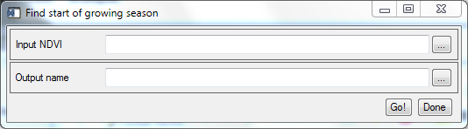

Explanation of the fields:

|  |  |
| --- | --- |
| Input NDVI | Select the NDVI time series |
| Output name | The filename of the output file. |

Output file band organization (11 bands total):

|  |  |
| --- | --- |
| Band | Description |
| 1 | Band number with the first non-zero NDVI value after the winter period |
| 2 | Maximum NDVI value of the set |
| 3-11 | In order of time the first 9 NDVI values of the time series starting at band number stored in band 1. |

### References:

Kogan, F. N. (1995). "Application of vegetation index and brightness temperature for drought detection." Advances in Space Research **Vol. 15**(11): 91-100.

van Wijk, R. E., A. Kölzsch, et al. (2012). "Individually tracked geese follow peaks of temperature acceleration during spring migration." Oikos **121**(5): 655-664.